**Project Title: - Start and Stop AWS Ec2 Instance As per Prefer time.**



**Introduction: -** Task about the rising cost of our production and need to save money by stopping our EC2 instances after all engineers are clocked out.

**Pre-requisite: -** AWS Account

**AWS Services used in the Task: -**

A) Ec2

B) IAM

C) Lambda

D) Cloud Watch

**Start performing Task: -**

***Step 1: Manually Launch EC2***

The first step in this project would be to manually launch any number of **EC2 instances**. These instances will be used solely as a means to test our lambda functions.

In the AWS console head over to the search bar and type in “EC2”. EC2 can also be found in services under the “**Compute**” submenu.

Once the EC2 dashboard is displayed, on the left-hand side click on the orange button title “***Launch Instance***”.

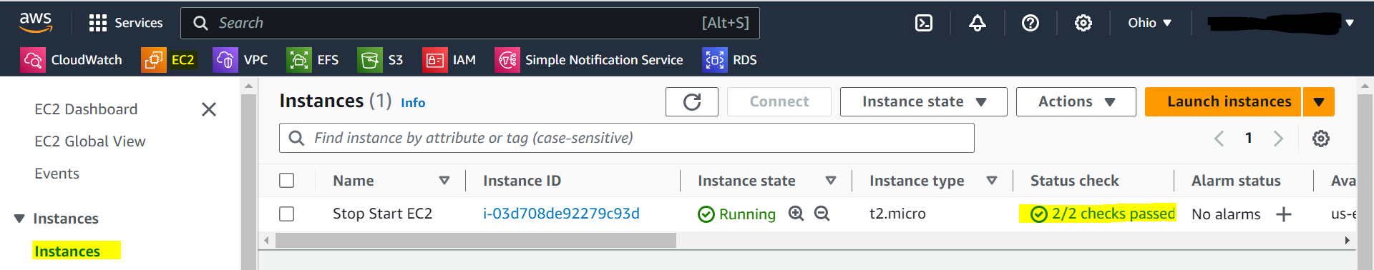

***Step 2: IAM Policy & Creation***

The second step in this project would be to create a policy and a role that will be used by our lambda function.

In the AWS console head over to the search bar and type in “IAM”. IAM can also be found in services under the “**Security, Identity, & Compliance**” submenu.

Once the IAM dashboard is displayed, on the left-hand side click on “**Policies**” and then click on the orange button title “***Create policy***”.

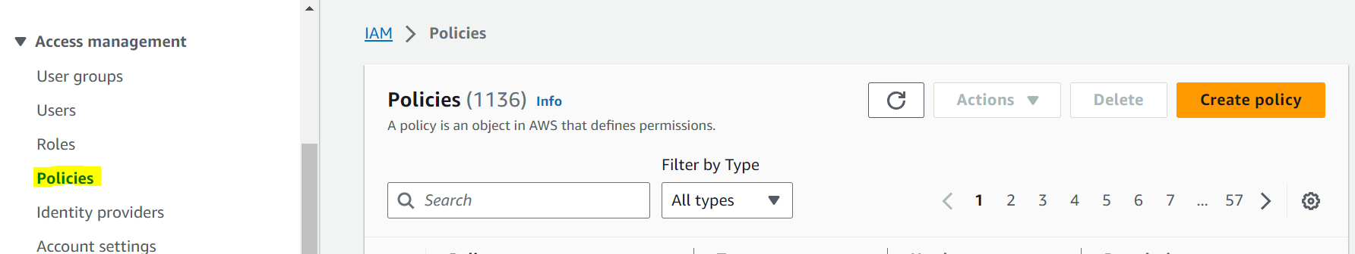

Under the “**Select Service**” menu type and select EC2. The next page should prompt you to select “**Access level**”.

For Write access select “**StartInstances, StopInstances**”.



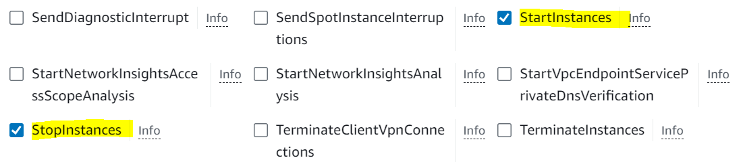

In the Resources click on **Add ARNs** After Filling all required information and click on **Add ARNs** then click on **Next**

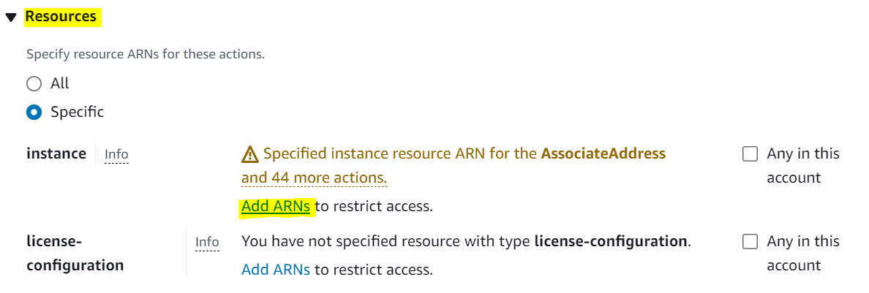  
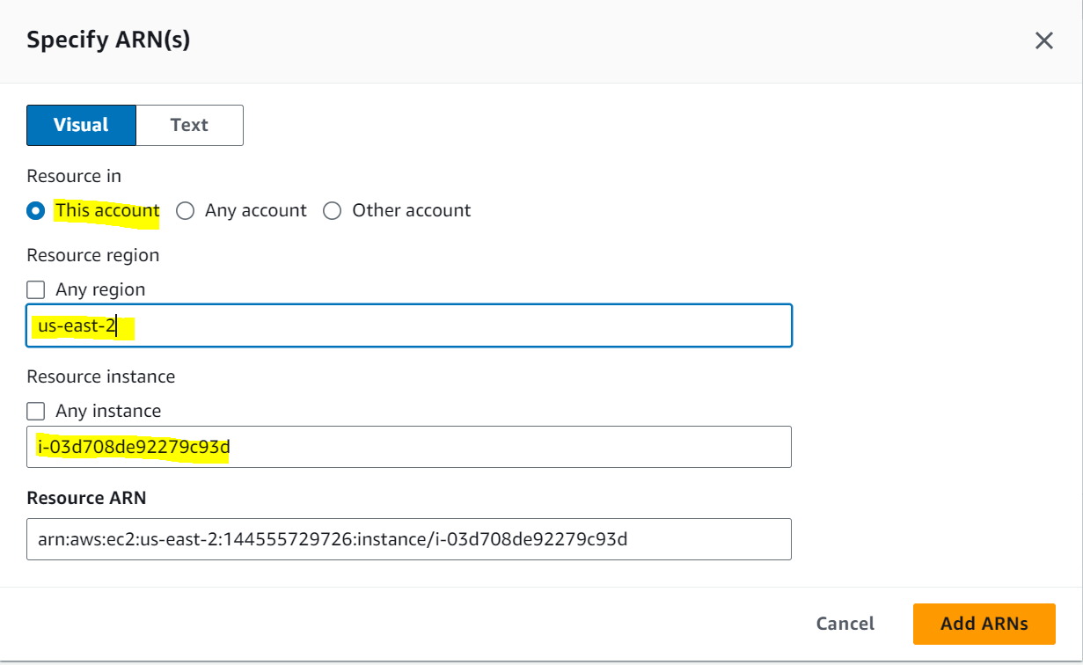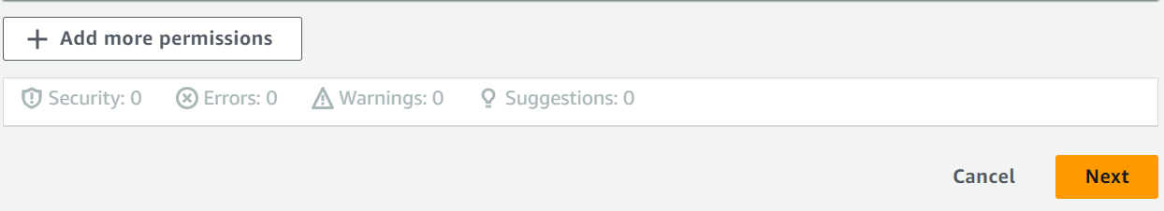

Add policy details and then click on **Create Policy**

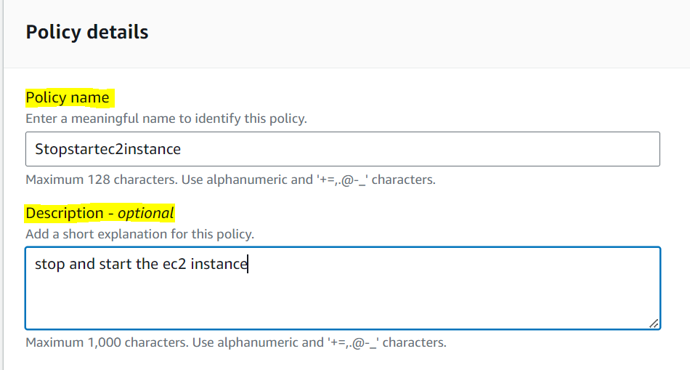



Once our policy has been created, on the left-hand side click on “**Roles**” and then click on the orange button title “***Create roles***”.

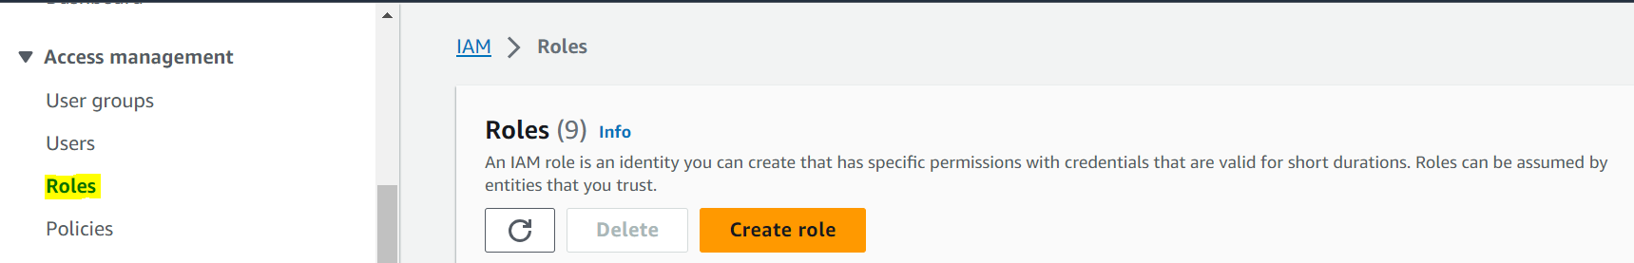

Select the “**AWS Service**” for “**Trusted entity type**” and “**Lambda**” for “**Use case**”, then click on “**next**”.

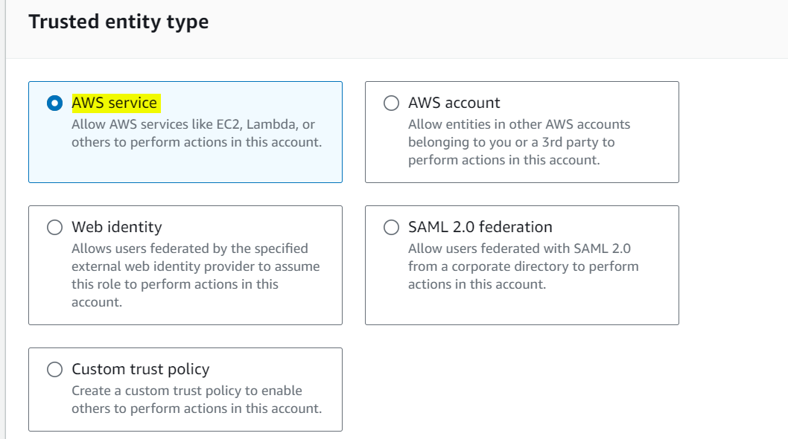

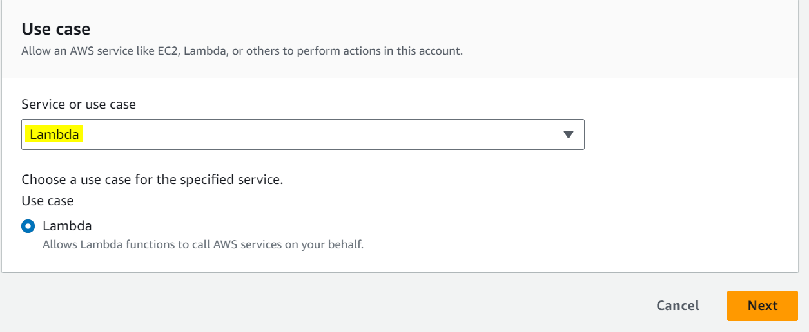

search and select the **policy** created in the steps above then click next.

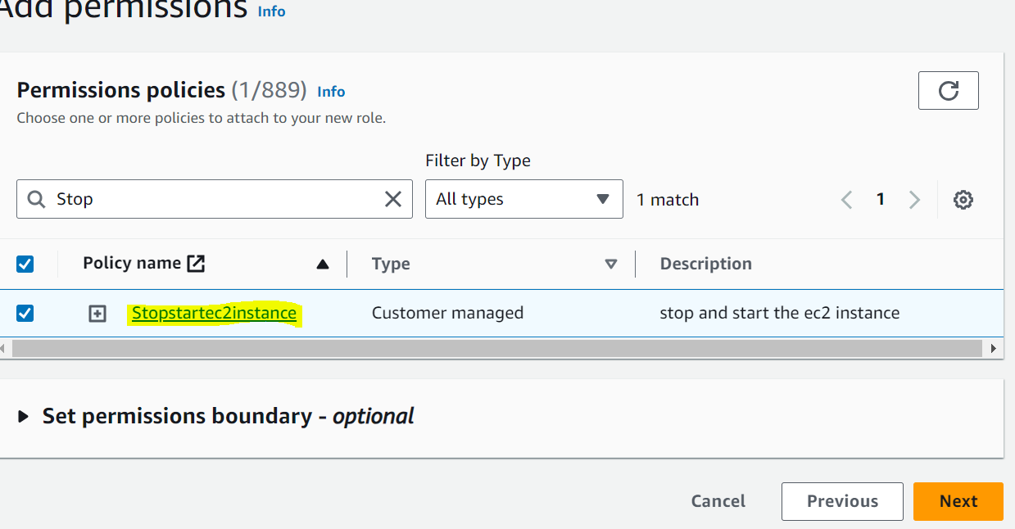

create a name and click on “**Create role**”.

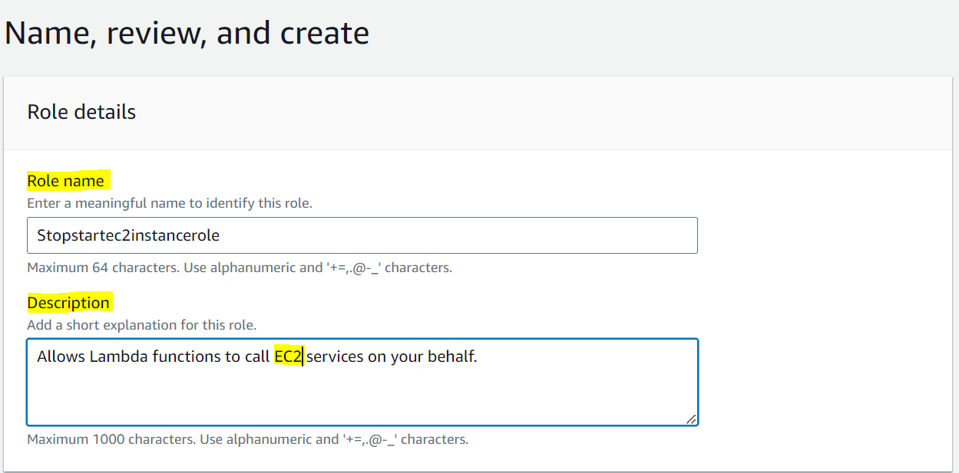

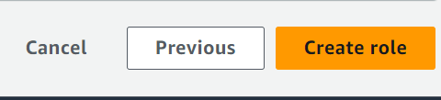

***Step 3: Lambda Functions Creation***

The third step in this project would be to create our lambda function. We are also going to assign the role we created in the step above in order for our function to be able to start and stop our instances as needed.

In the AWS console head over to the search bar and type in “Lambda”. Lambda can also be found in services under the “**Compute**” submenu.

Once the Lambda dashboard is displayed, on the right-hand side click on the orange button title “***Create functions***”.

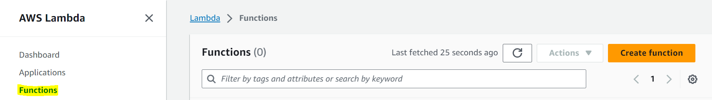

Author from scratch

Create a name for our function.

Select **“Python 3.11”** for our runtime.

Select the role we created earlier under the **“Change default execution role”** option.

Then click on “**Create functions**” for **stop** running ec2 Instance

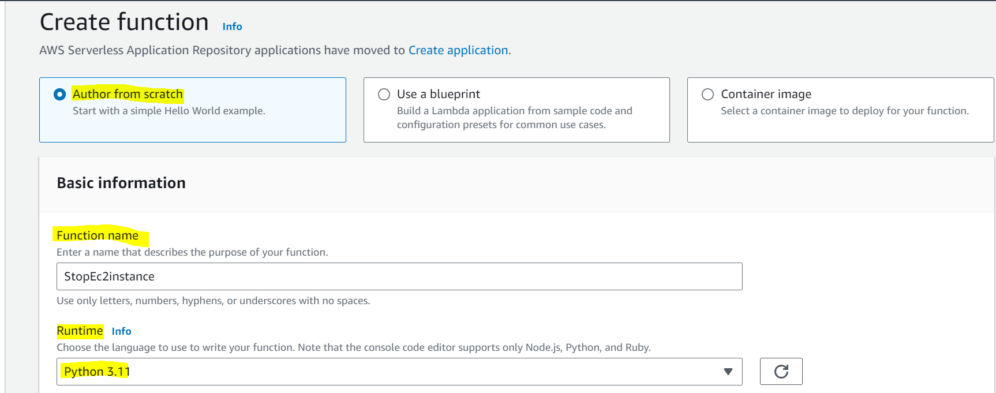

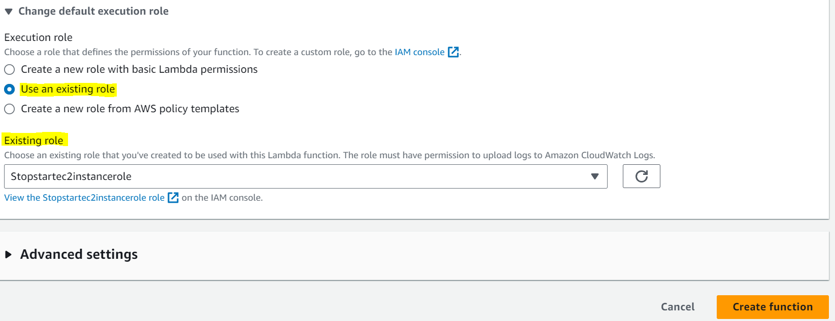

* Python code needed to **Stop**

**### Stop the instances by using python code: -**

import boto3

region = 'us-west-1'

instances = ['i-12345cb6de4f78g9h', 'i-08ce9b2d7eccf6d26']

ec2 = boto3.client('ec2', region_name=region)

def lambda_handler(event, context):

ec2.stop_instances (InstanceIds=instances)

print ('stopped your instances: ' + str(instances))

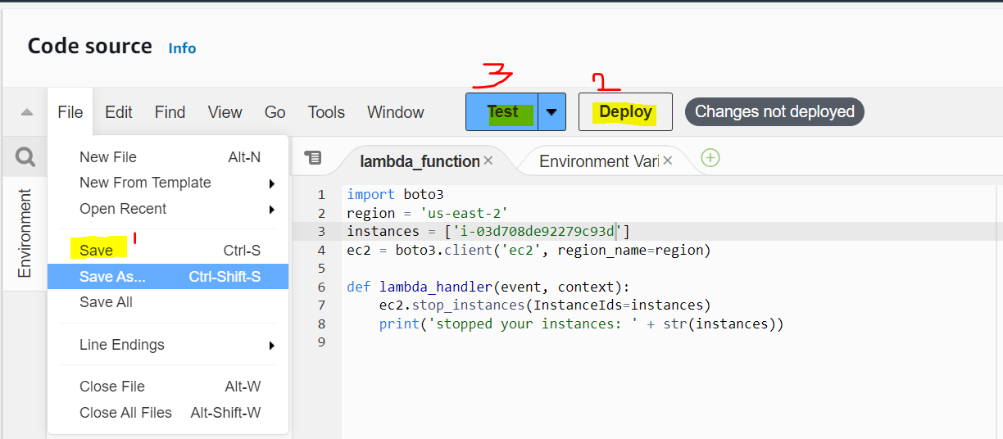

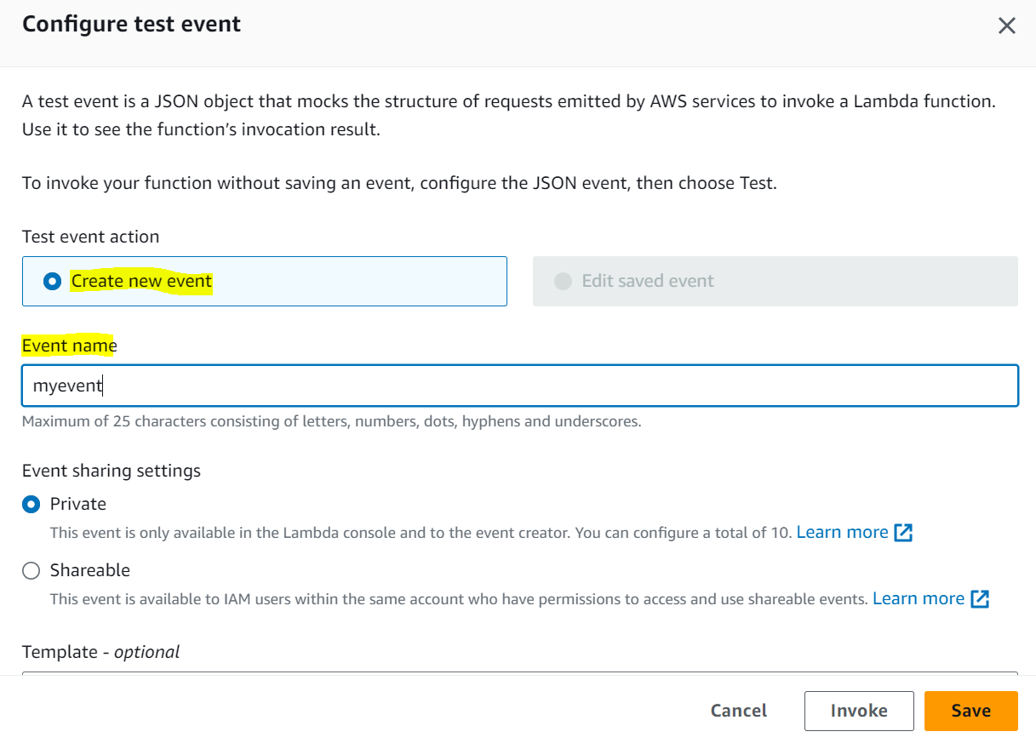

After creating Event then Click on **Test** and go back to the Ec2 and confirm our Ec2 is going to on stop stage or not.

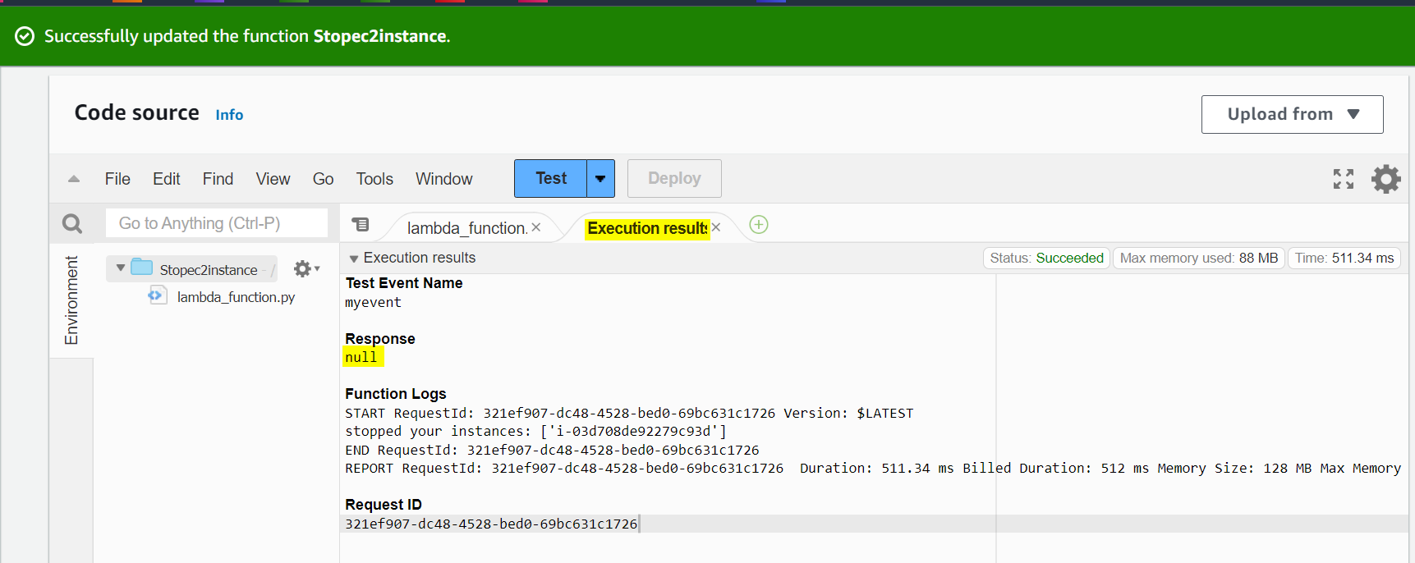

**Status of Ec2 Instance**

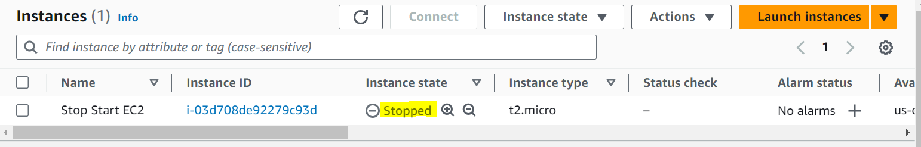

* Create Lambda function for **Start Ec2** Instance



Author from scratch

Create a name for our function.

Select **“Python 3.11”** for our runtime.

Select the role we created earlier under the **“Change default execution role”** option.

Then click on “**Create functions**” for **Start** Stopped ec2 Instance

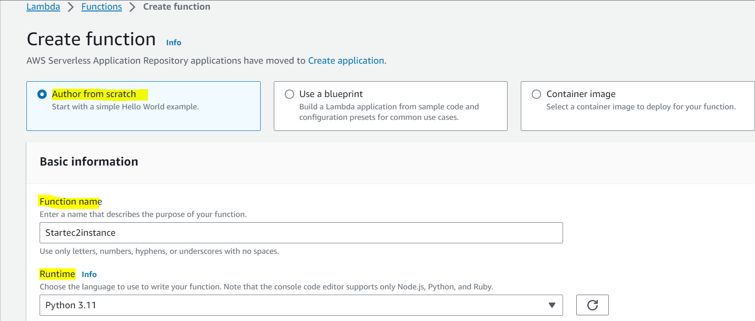

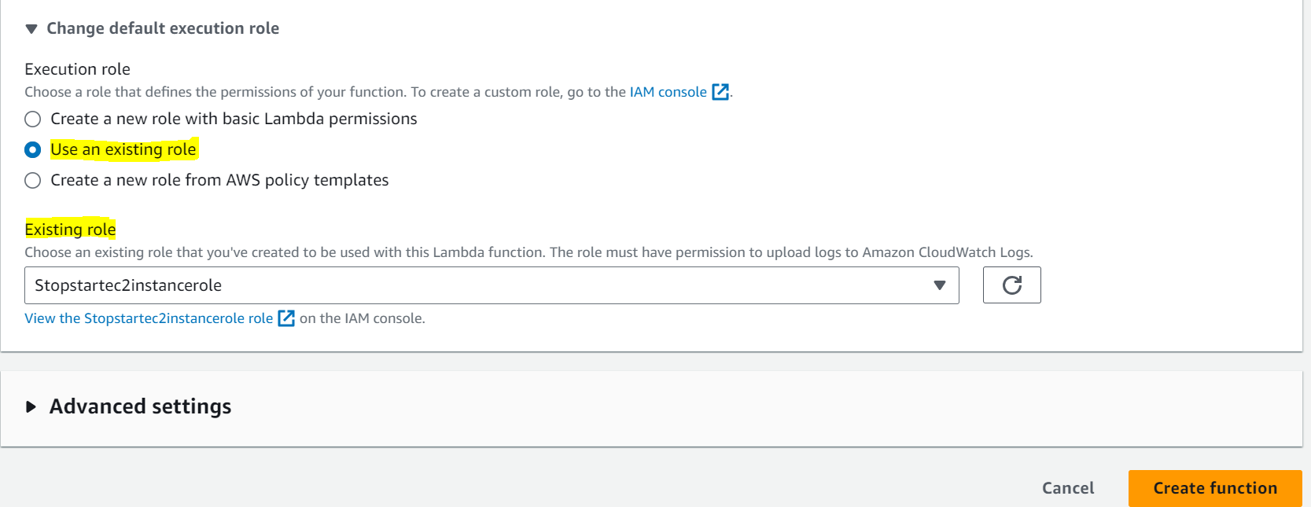

**## Start** our ec2 instances by using python code.

import boto3

region = 'us-west-1'

instances = ['i-12345cb6de4f78g9h', 'i-08ce9b2d7eccf6d26']

ec2 = boto3.client('ec2', region_name=region)

def lambda_handler(event, context):

ec2.start_instances (InstanceIds=instances)

print ('started your instances: ' + str(instances))

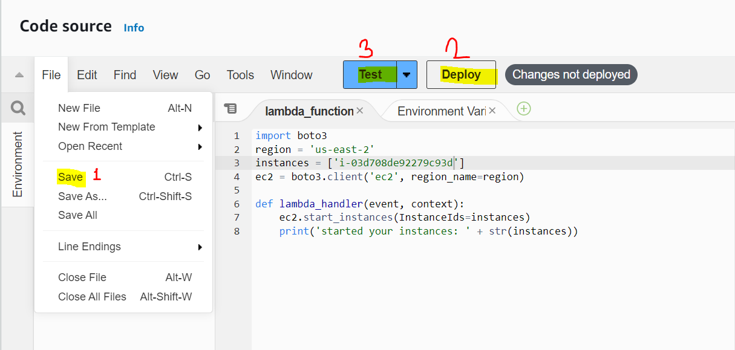

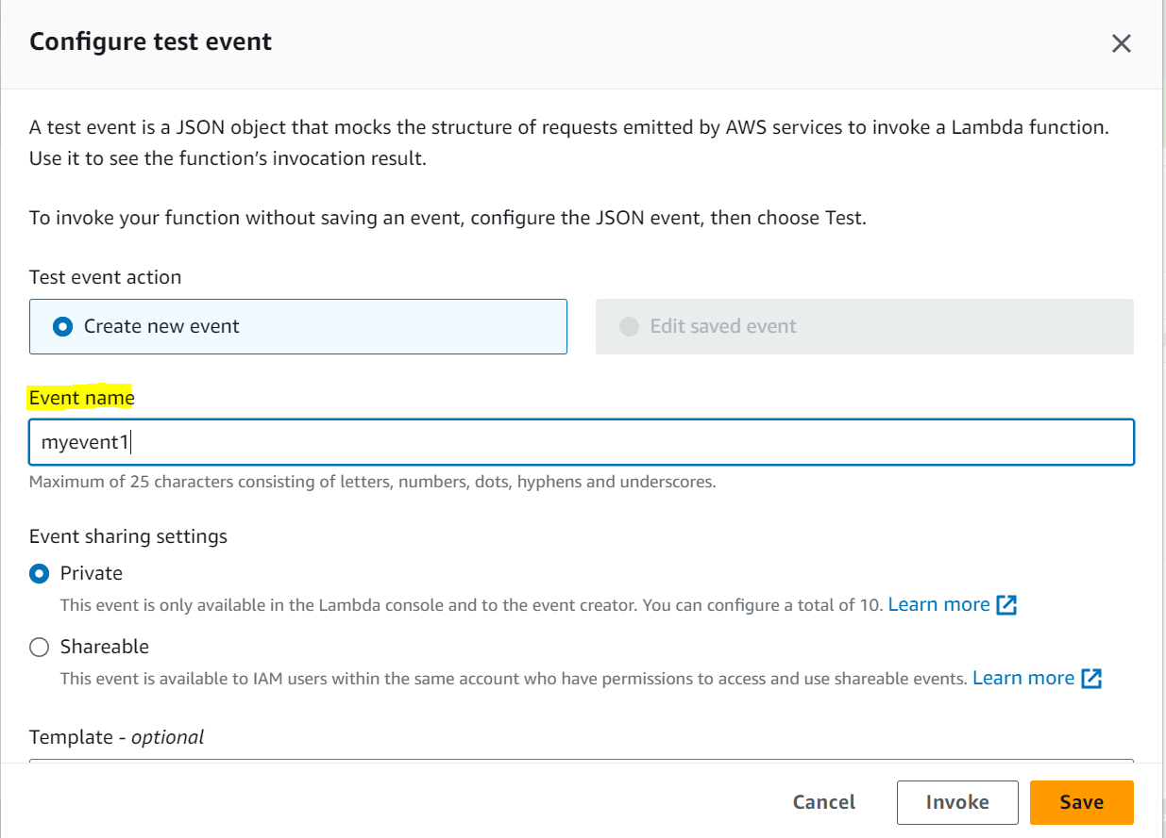

After creating Event then Click on **Test** and go back to the Ec2 refresh and confirm our Ec2 is going to **start** or not.

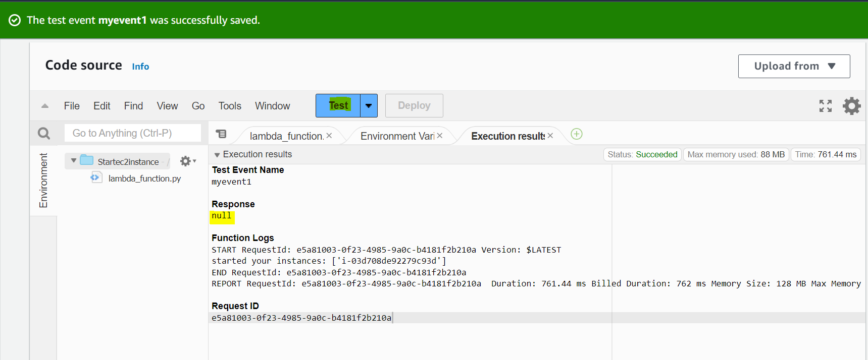

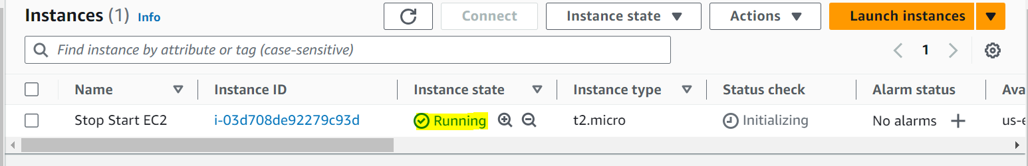

# ***Step 4: Create the API Gateway and associate with the lambda function***

Go to API Gateway app

Go to Create API and select “HTTP API”

In the AWS console head over to the search bar and type in “API Gateway”

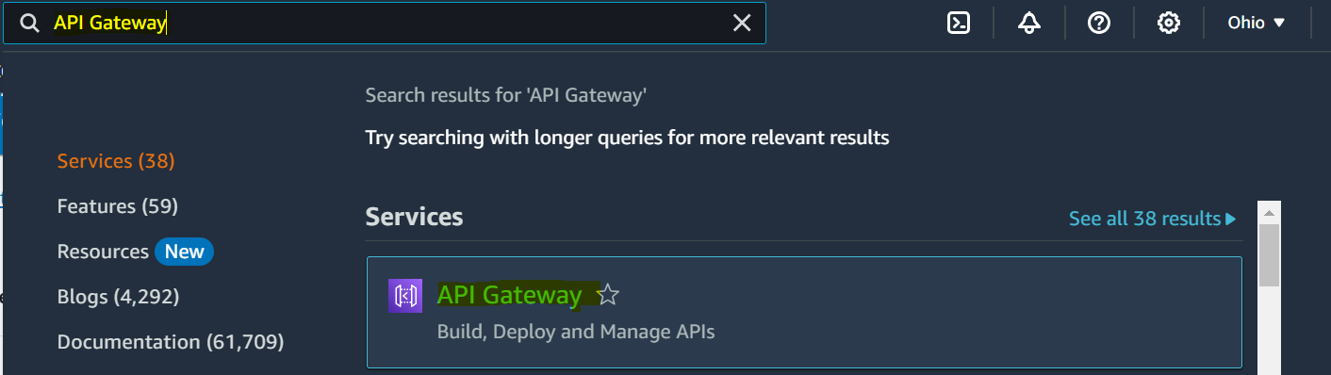

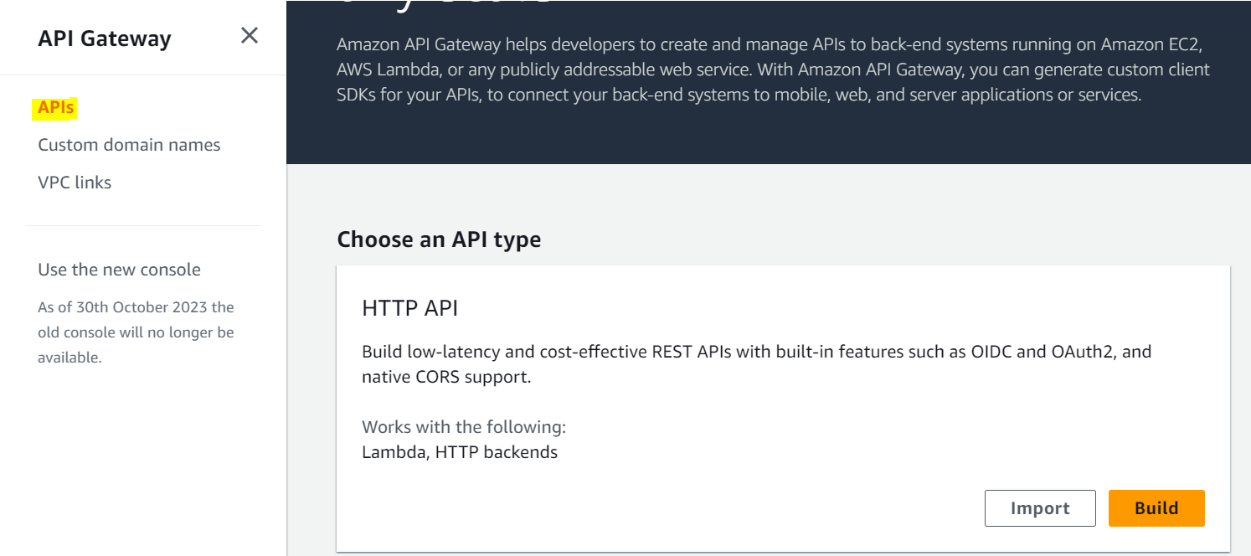

Click On **Build Then** Select **Lambda Integration type**, as a **Lambda** your region. You’ll be able to locate your **stop and** **Start** Lambda function in the dropdown list and fill your **API name** then click on **Nex**t

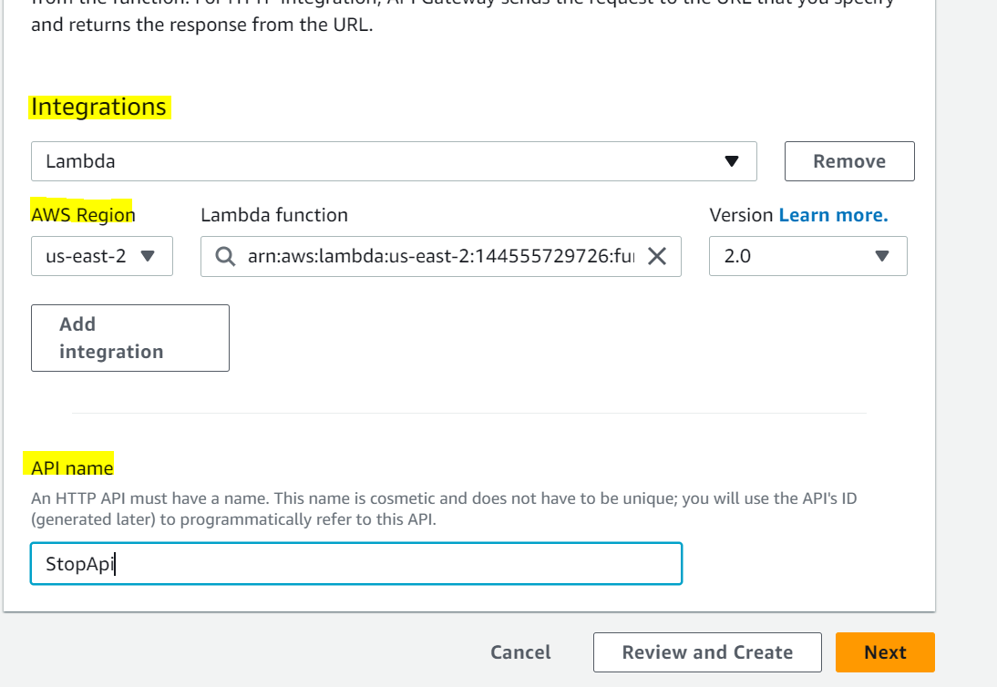

Configure your **API routes.** Then click on **Next**

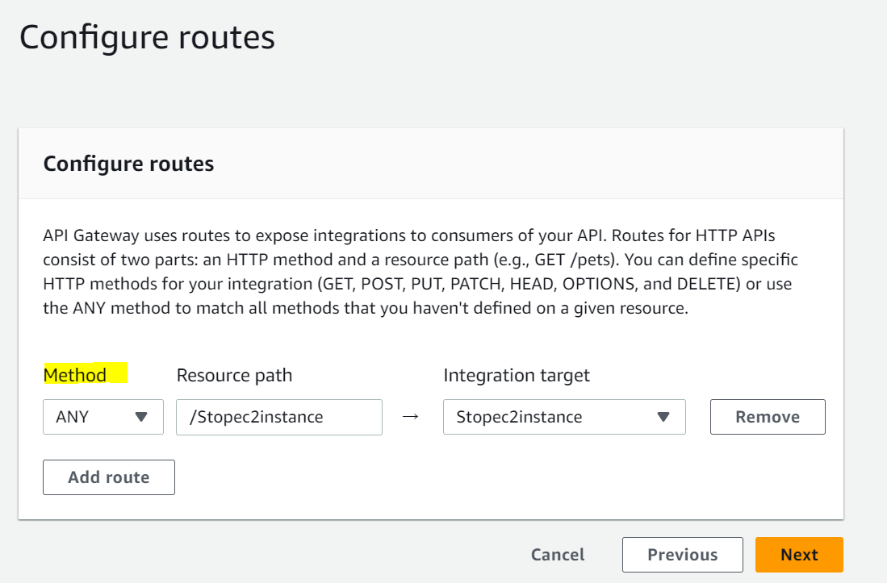

You can have several stages (stage, pre-prod, prod) for a route. Make sure to turn off the Auto-deploy feature. Add your **configure stages** then click on **Next** and then click on **create**

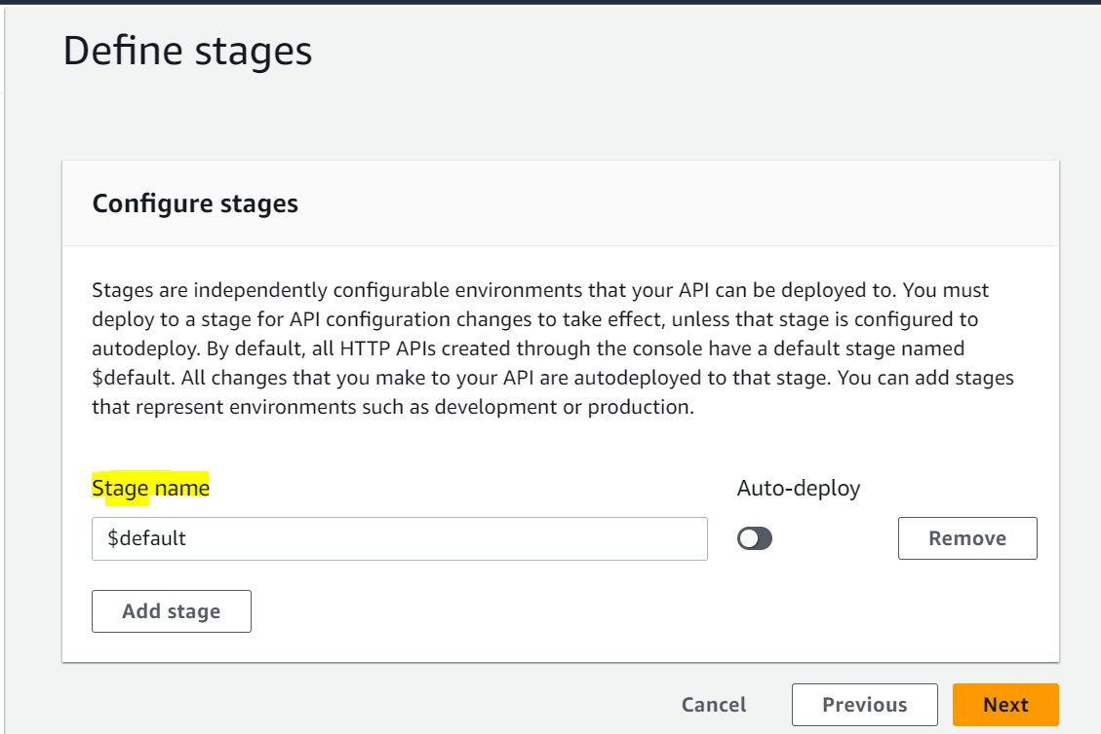

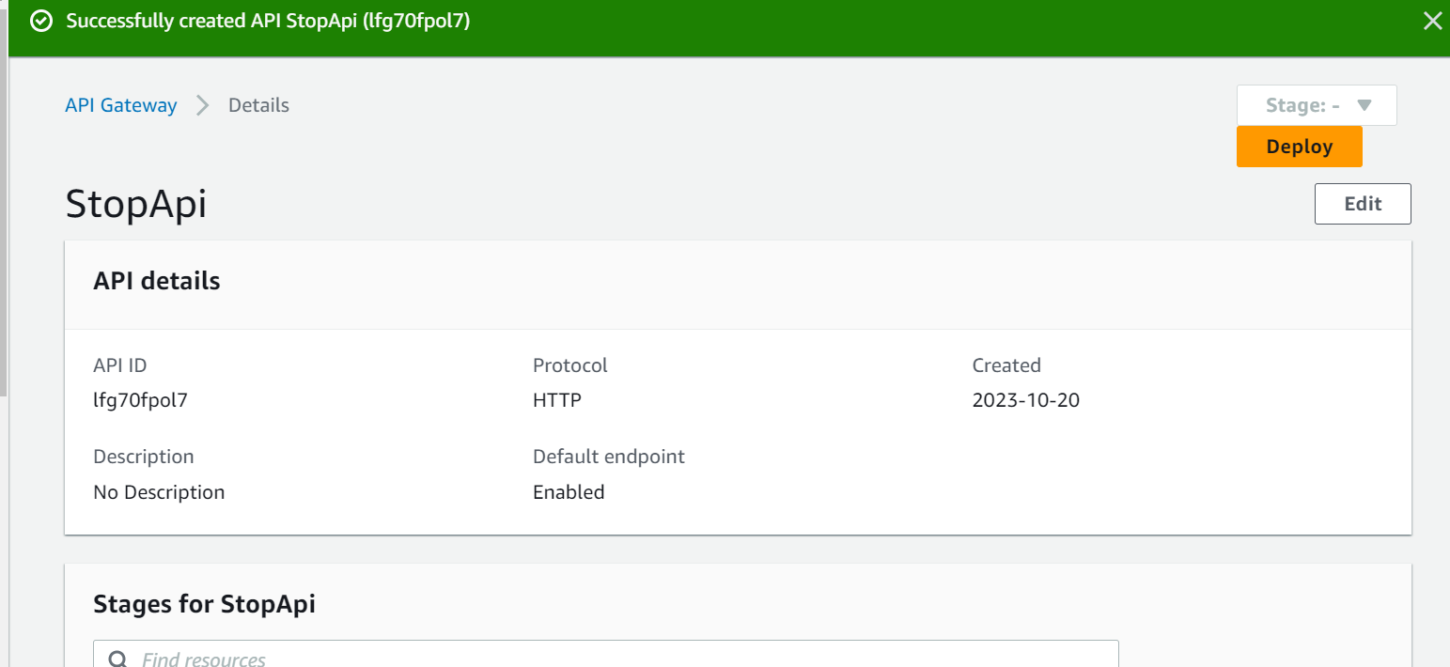

Go back to the **Lambda function** and choose **stop function**

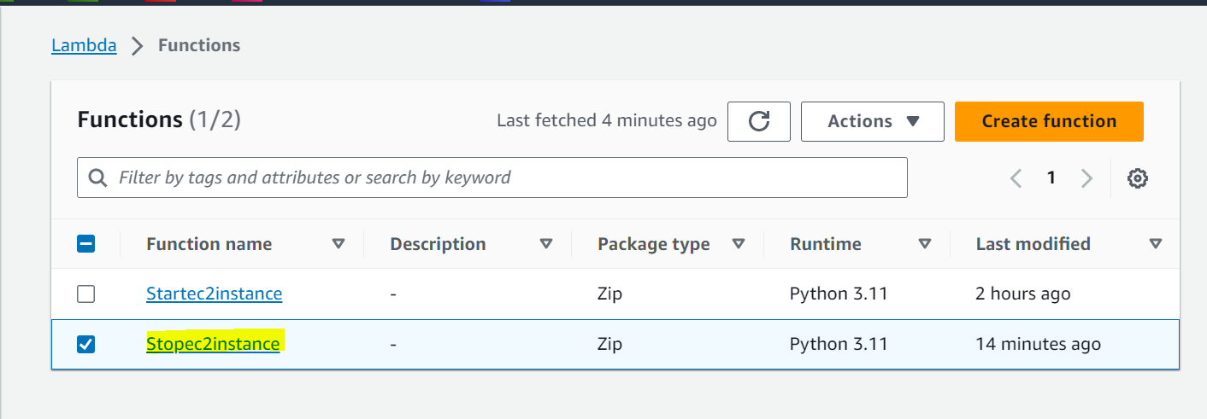

click on that **stop function** then click on **Configuration** then click on **Add**

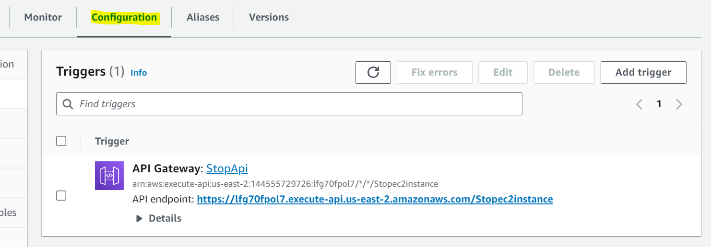

Select **API Gateway** and click on **Add trigger** and choose **API Gateway**

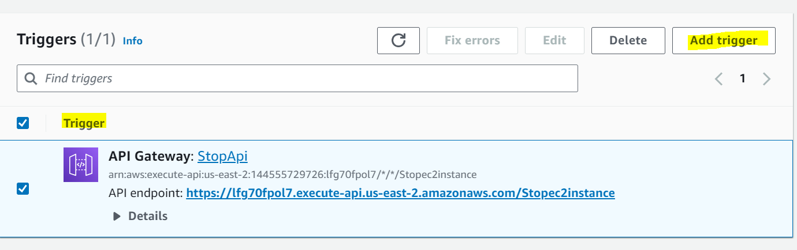

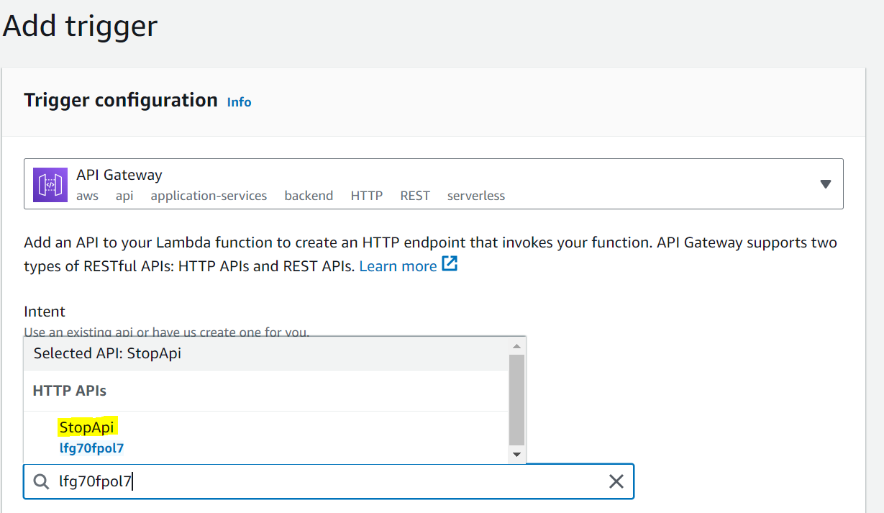

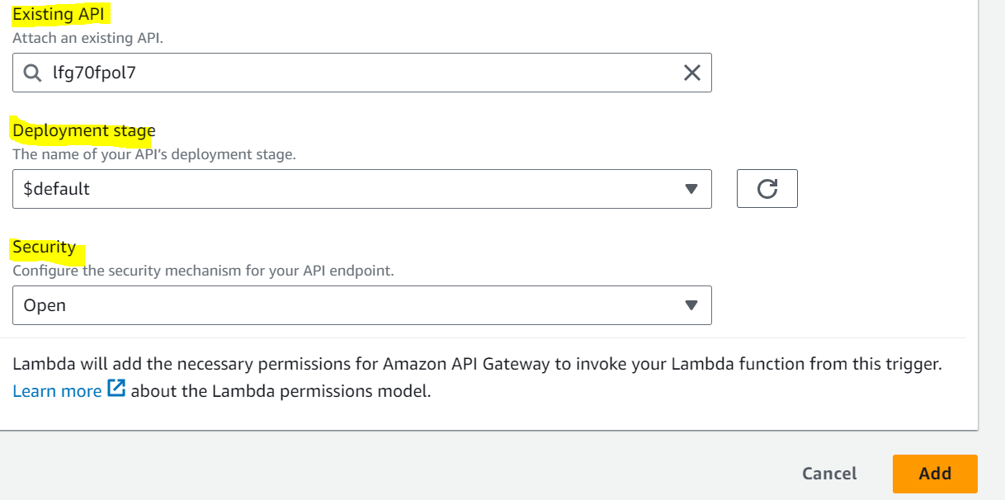

Click on **API Endpoint URL** and go back to **Ec2 dashboard** and check Instance status

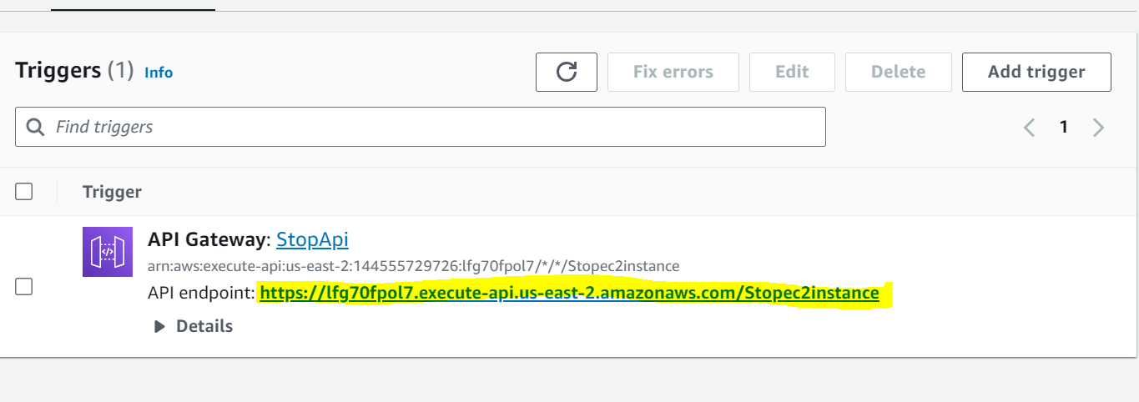

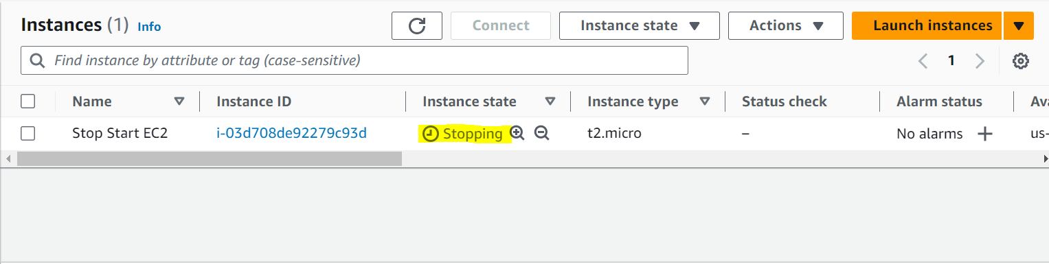

* **Start EC2 Instance by triggering API Endpoint**

Go to API Gateway then click on **Create API**

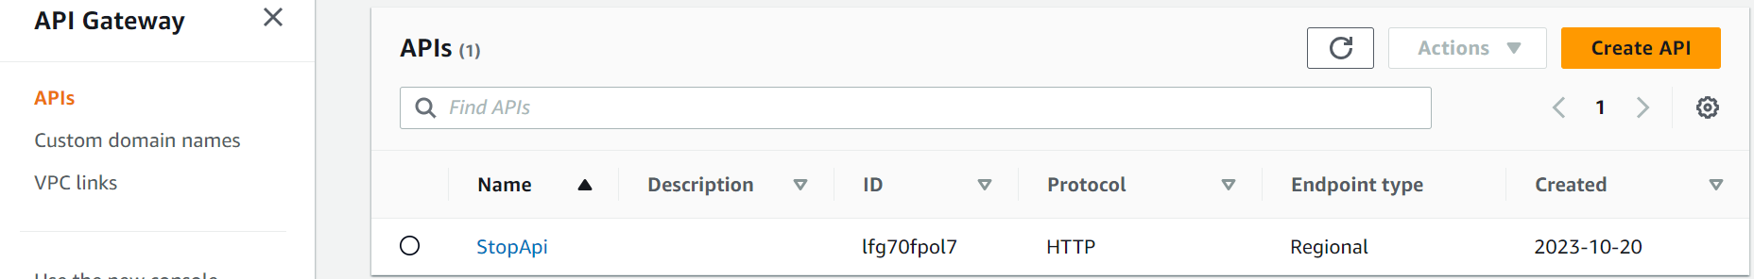

Choose API Type **Click on Build**

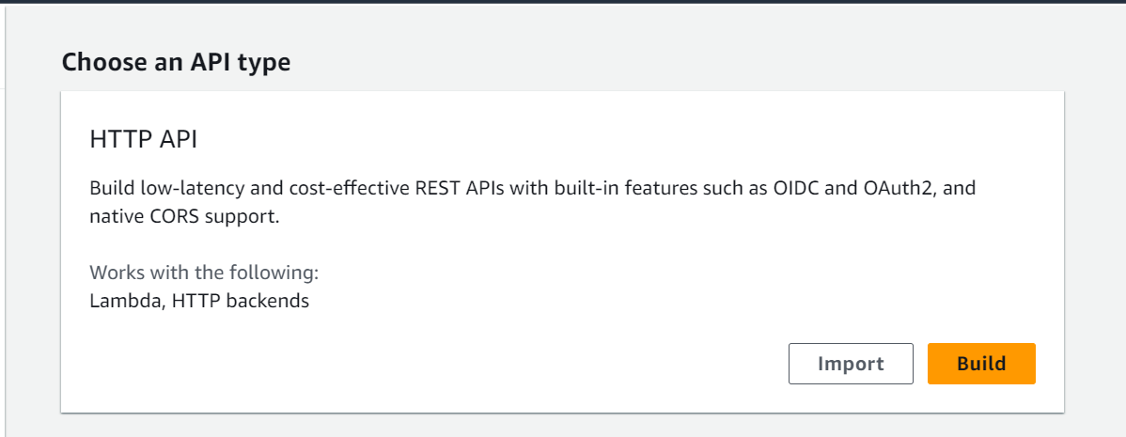

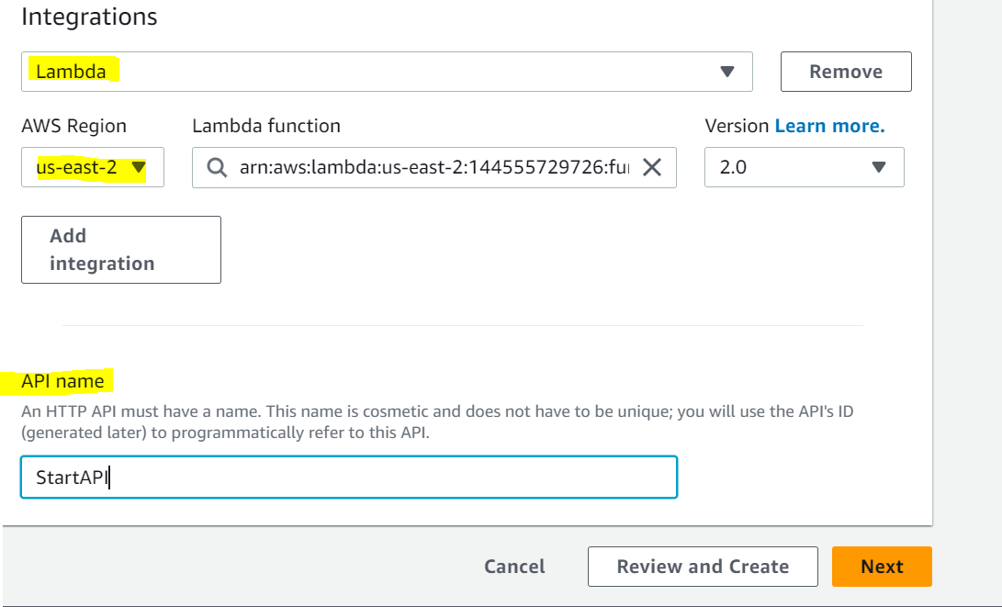

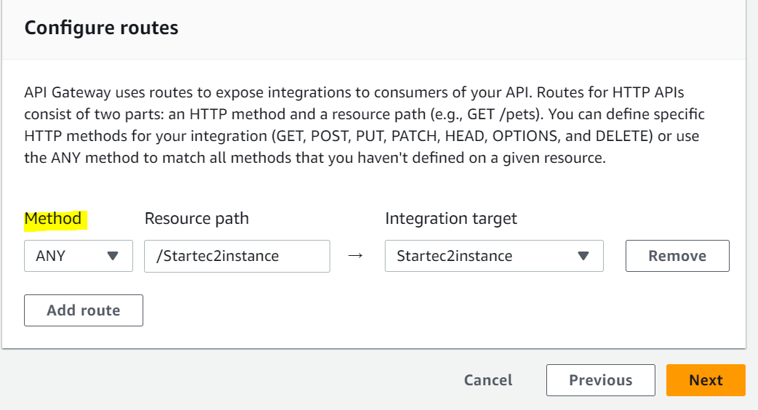

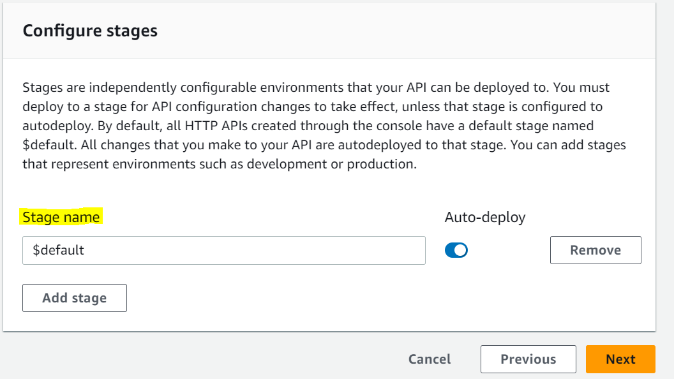

Then Click on **Create**

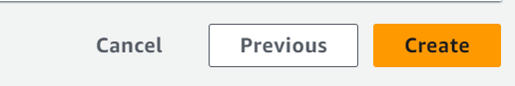

Go back to the **Lambda function** and choose **Start function**

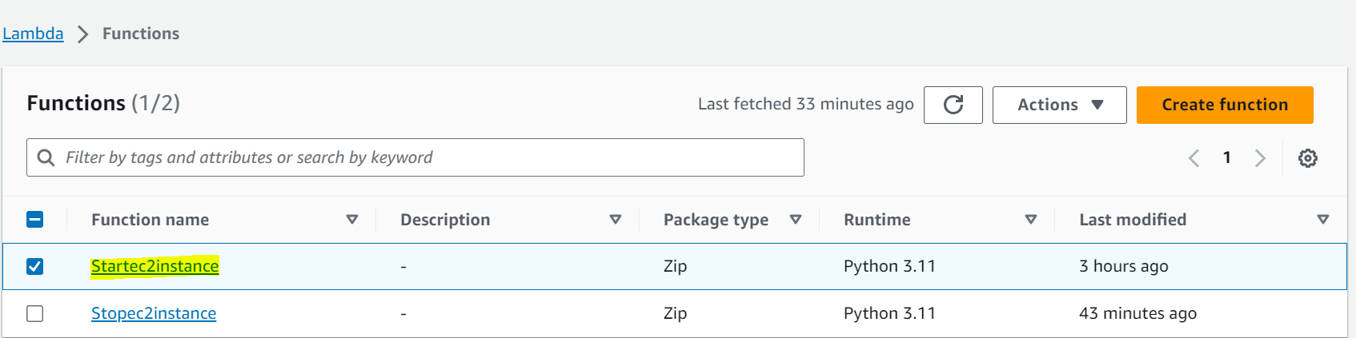

click on that **Start function** then click on **Configuration** then click on **Add**

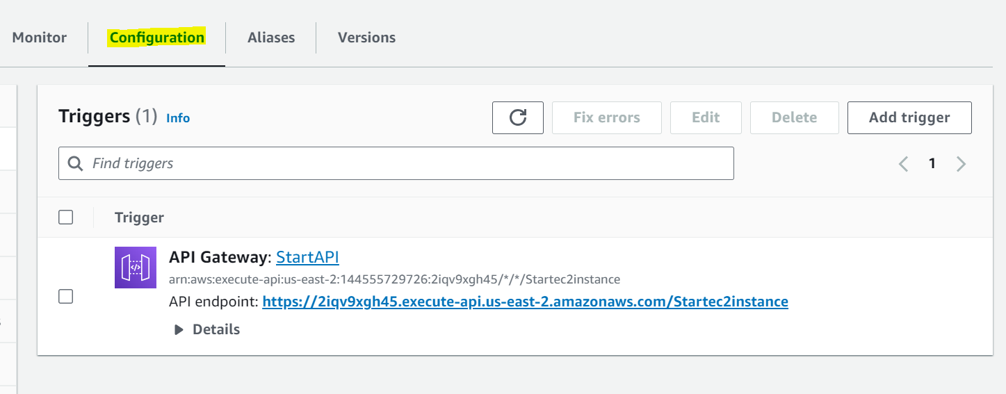

Select **API Gateway** and click on **Add trigger** and choose **API Gateway**

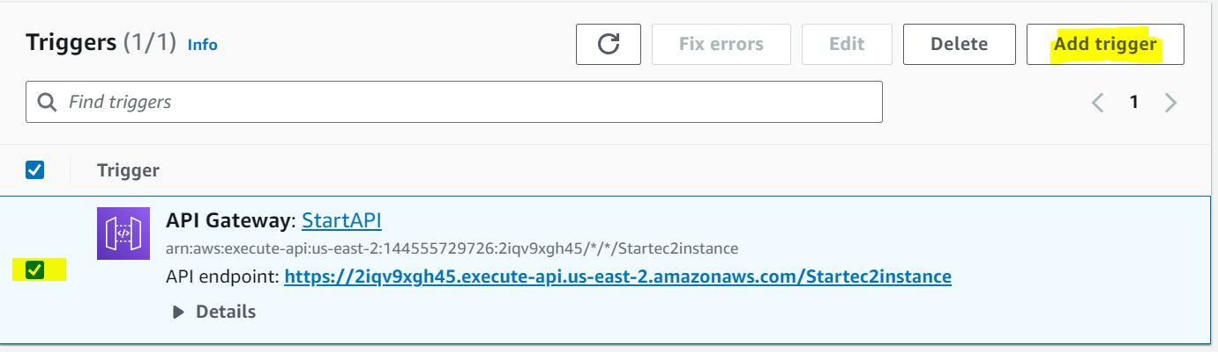

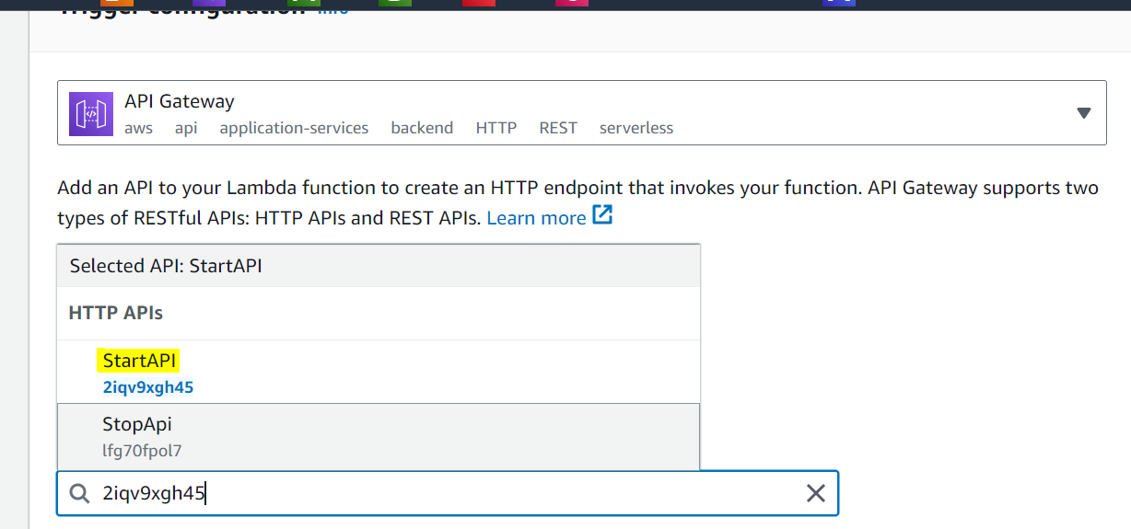

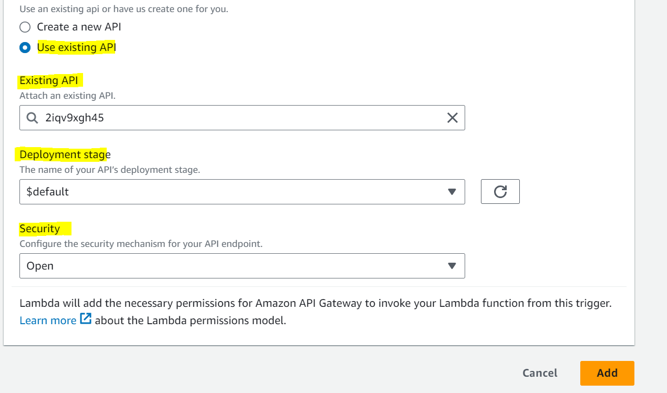

Click on **API Endpoint URL** and go back to **Ec2 dashboard** and check Instance status

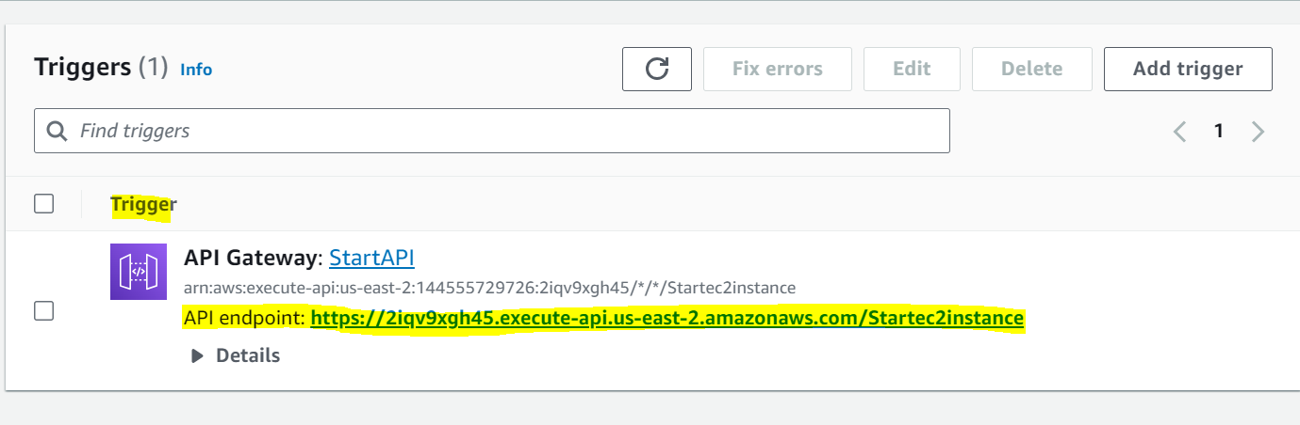

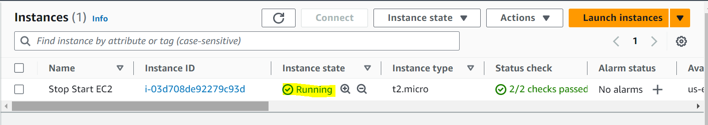

***Step 4: Create EventBridge Rule to Trigger EC2 Instances By using AWS Cloud Watch Service and start***

In this step, we are going to create an **EventBridge** Rule that triggers our EC2 instances. Being that Lambda is triggered by events, whenever an EC2 instance is stopped, it’s going to send an event that will trigger our function.

In the AWS console head over to the search bar and type in **“EventBridge”.** Once the page is displayed, on the right-hand side click on the orange button title **“*Create rule*”.**

Provide a name and a description and under rule type select “***rule with an event pattern***”.

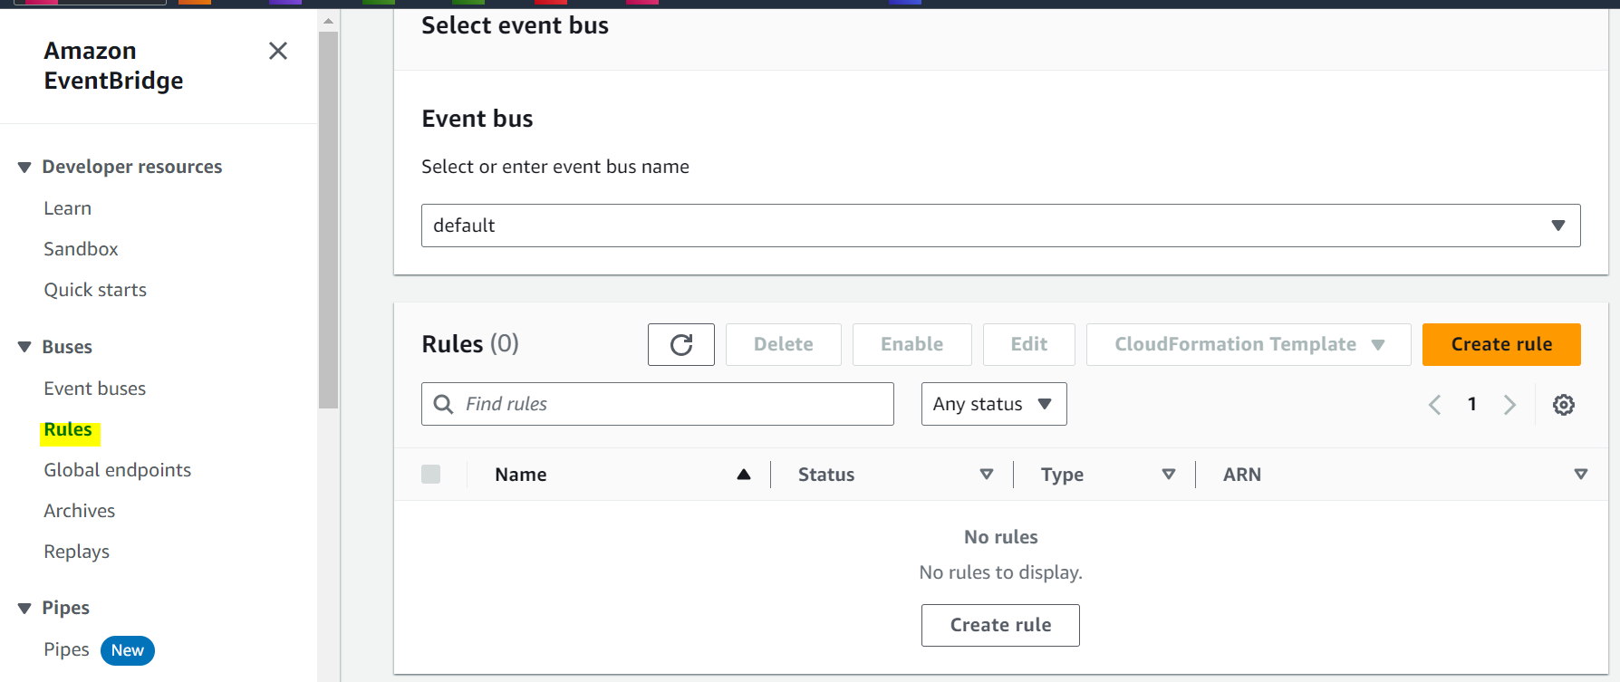

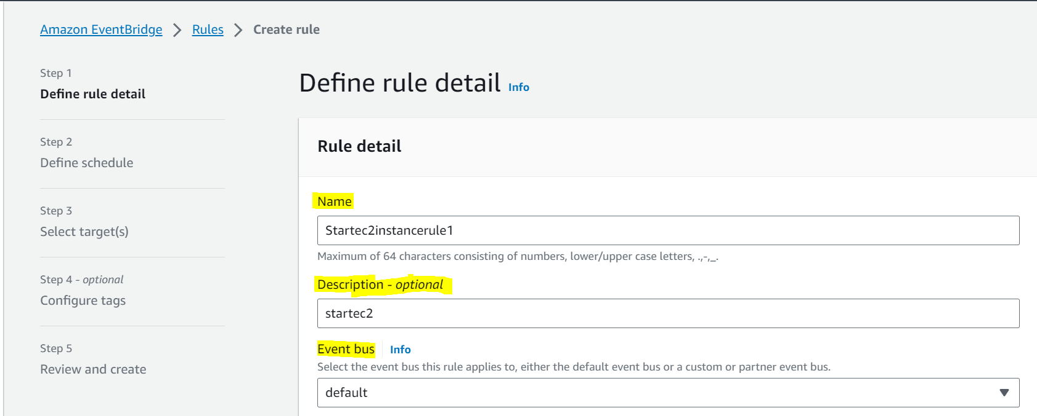

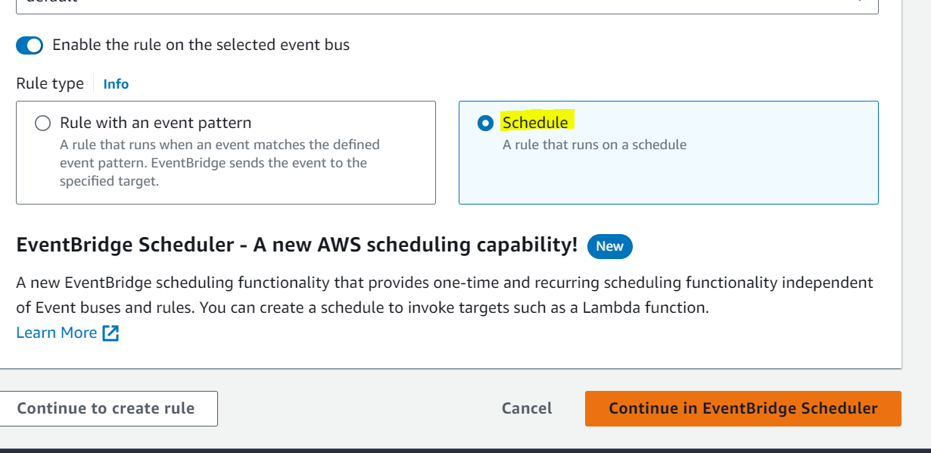

Fill all requirement as per your demand then click on **Next**

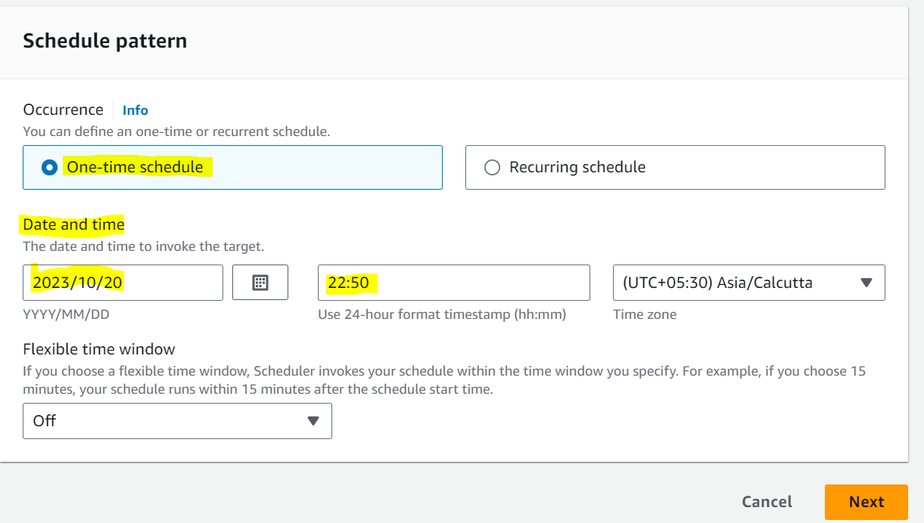

For event source select **AWS Services**.

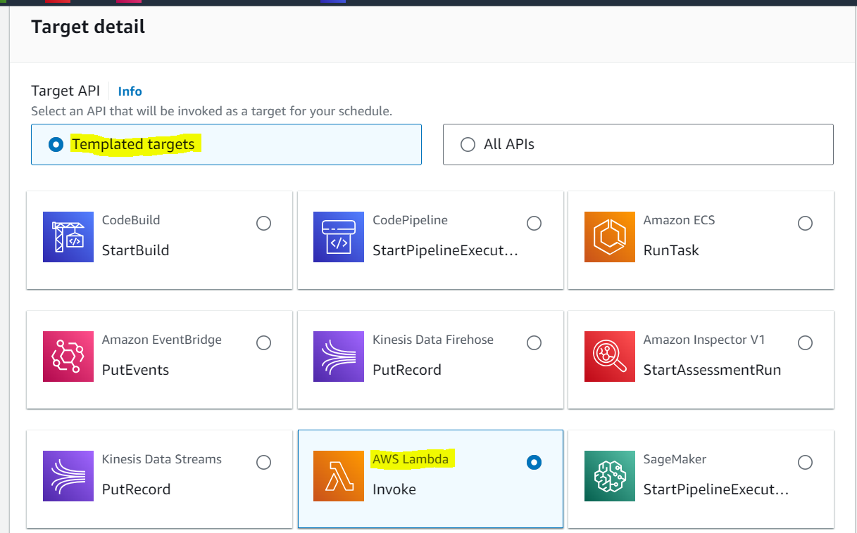

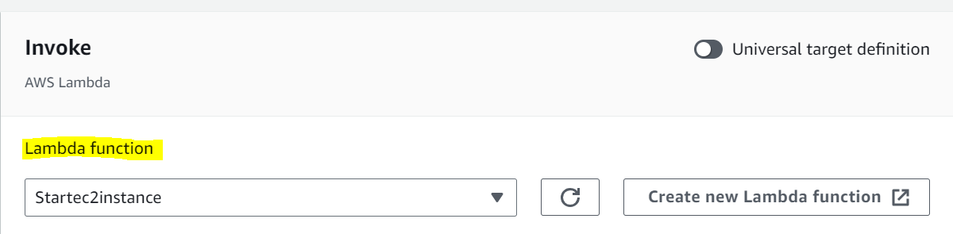

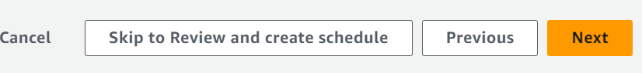

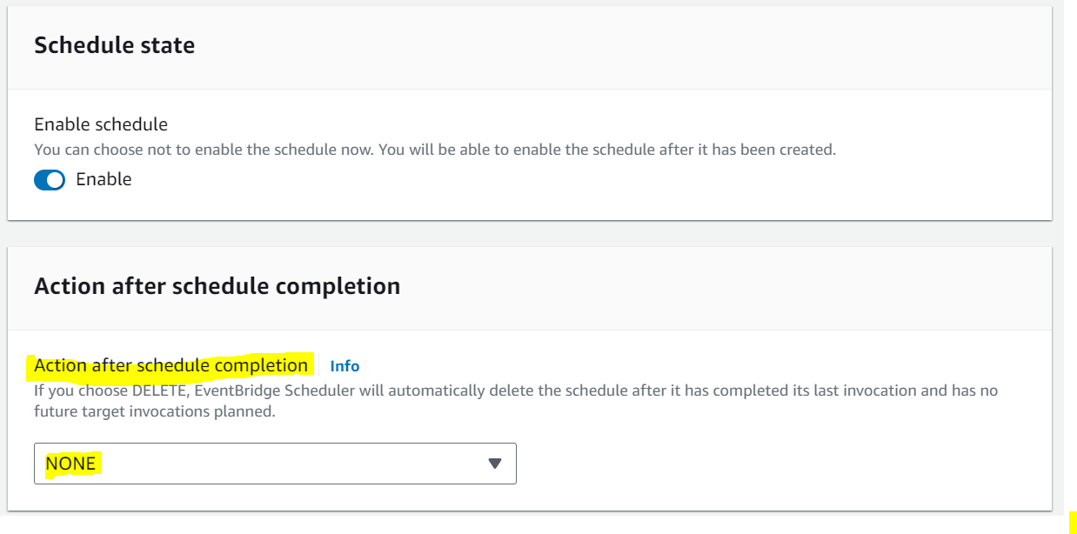

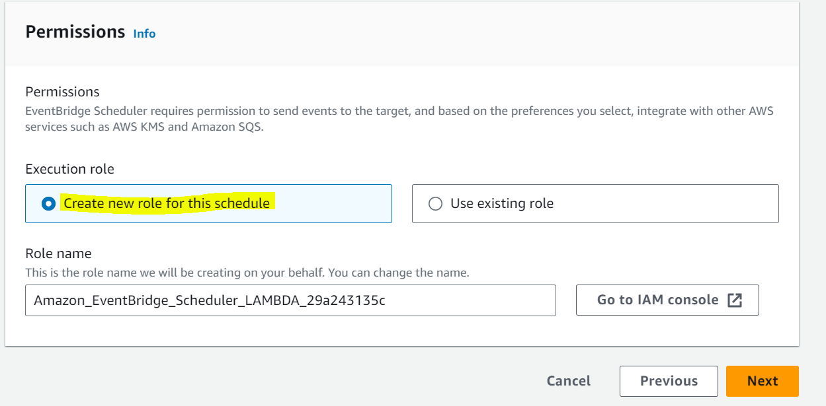

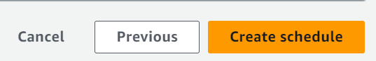

**After Clicking on create schedule Then go back to Ec2 console and check Instance status**

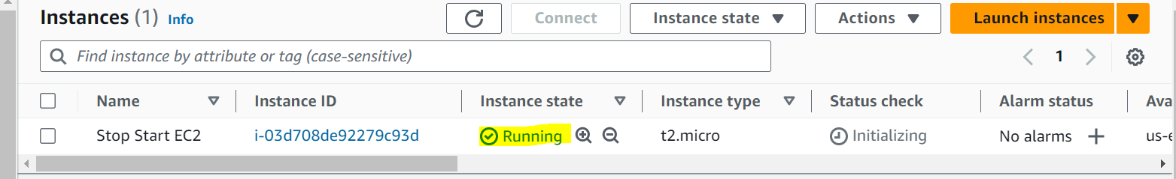

**Create EventBridge to Stop the EC2**

In this step, we are going to create an **EventBridge** Rule that triggers our EC2 instances. Being that Lambda is triggered by events, whenever an EC2 instance is stopped, it’s going to send an event that will trigger our function.

In the AWS console head over to the search bar and type in **“EventBridge”.** Once the page is displayed, on the right-hand side click on the orange button title **“*Create rule*”.** For Stop the Ec2

Provide a name and a description and under rule type select “***rule with an event pattern***”.



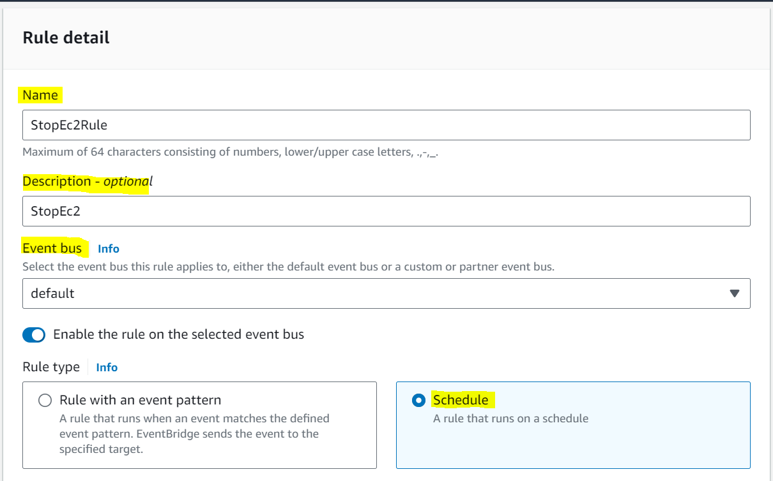

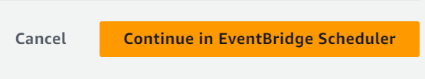

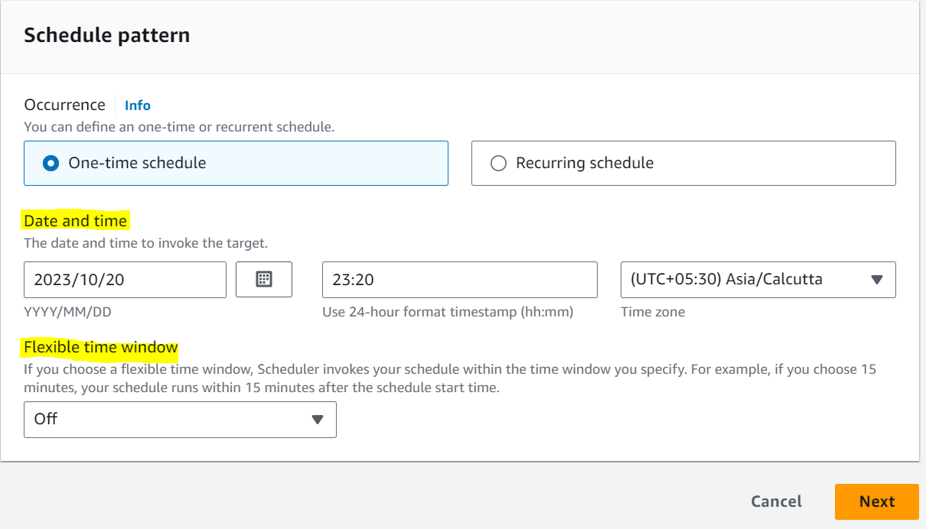

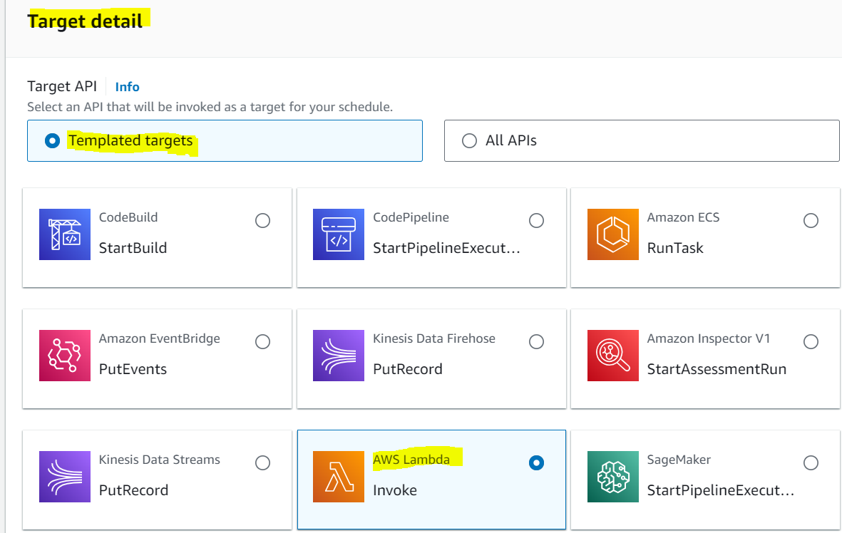

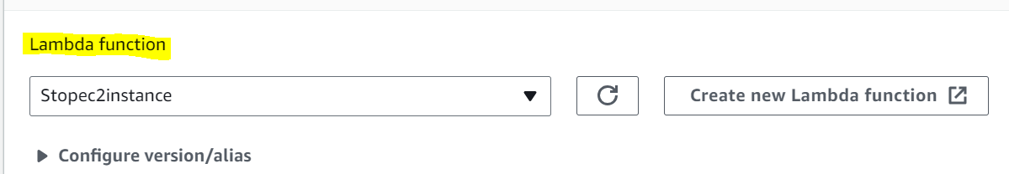

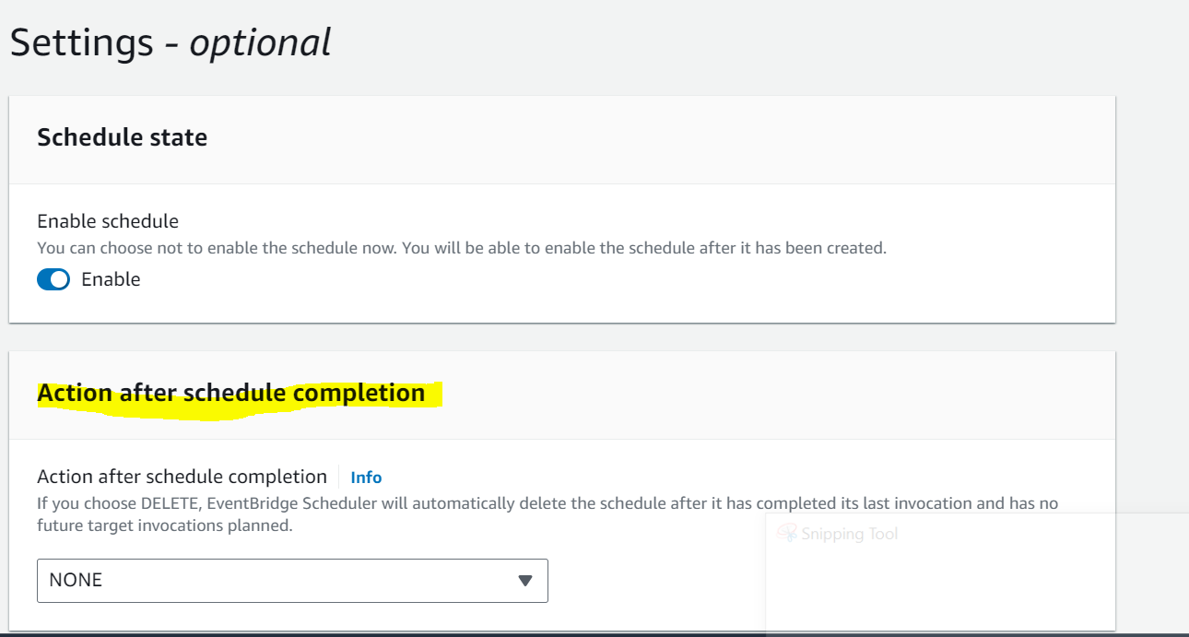

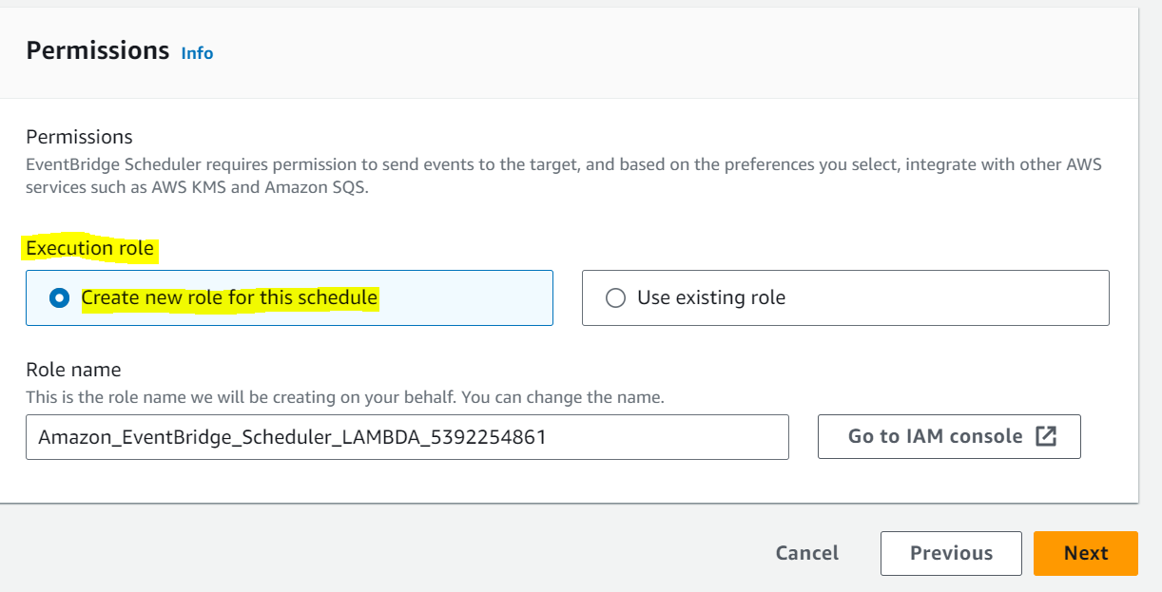

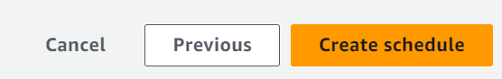

**After Clicking on create schedule Then go back to Ec2 console and check Instance status**

